**Federation University Australia at IIBIT (Sydney)**

**School of IT**

**Sydney Campus**

|  |
| --- |
| ITECH 3209 |

Course Number

**Group Members**

|  |  |  |  |
| --- | --- | --- | --- |
| Last Name | Given Names | Role | Student ID |
| Shrestha | Pranish | Scrum Master | 30345392 |
| Poudel | Madan | Team Member | 30338401 |
| Ghimire | Nabin | Team Member | 30349622 |
| Shrestha | Kanchan | Team Member | 30344274 |
| Joshi | Paras | Team Member | 30347755 |

**Course Name:** Project 2

**Group:** 6

**Program of Study:** Bachelor of Information Technology

**Lecturer:** Mr. Ahmad Saeed

**Tutor:** Mr. Nellai Seetharaman

**Title of Assignment:** Final Product

**Due Date: 14th June 2020 Date Submitted: 12th June 2020**

**DECLARATION:**

We have kept a copy of this assignment/work so that we can produce it if the original is lost or damaged. We hereby certify that no part of this assignment/work has been copied from any other student’s present or previous, published or unpublished, professional or amateur work or from any other source except where due acknowledgement is made in the assignment. We further certify that no part of this assignment/work has been written/produced for us by any other person except where such collaboration has been authorized by the unit/subject lecturer/tutor concerned.

**--Madan -----Nabin------Pranish-------Kanchan--------Paras------**

Table of Contents

GitHub Link 3

Website Link 3

Register Account 3

Forgot password 4

Log In 5

Create an order 5

Edit an order 6

Logout 6

Find the customers 7

Delete shopping cart products 7

Manage the inventory 8

Check the delivery time 8

Make payment 9

Print a tax invoice 10

Feedback 11

View/edit Profile 12

Create/ manage categories 13

Track shipments 13

Shopping cart 14

Confirmation email 14

Online accounts 15

Refund 15

Enter promotional codes 16

Check the Stock through product cards 17

Creating the inventory stock 17

Creating Backup in local storage 17

Editing inventory Details 18

Viewing the pending orders 18

Editing Order 18

Generate Logistic report 19

Notification Panel 20

View Items by Category 20

View product Detail 21

Watch it later Section 21

# GitHub Link

Link: <https://github.com/PranishShresth/Order-Management-System>

# Website Link

Link: <https://ordermanagementsystemv1.herokuapp.com/>

Alternatively, please scan this QR code to access the website link.



# Register Account

User can register onto the website with their Email, Username and Password.

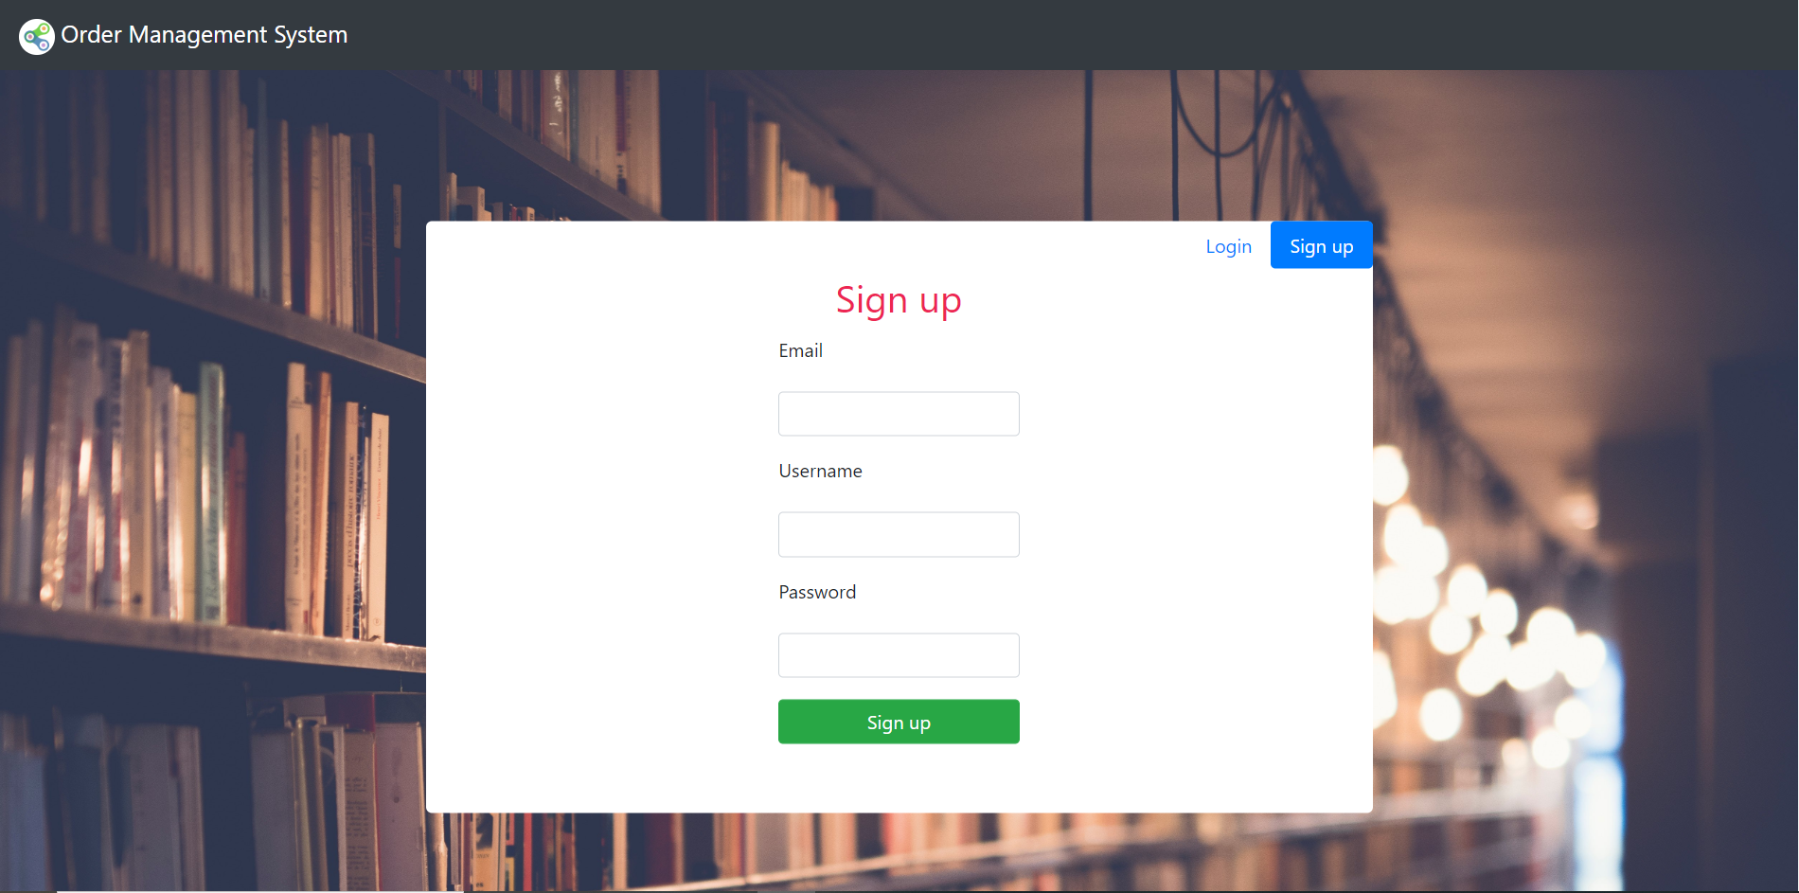

After successful signup, user will get an email saying that their details have been registered in the system.

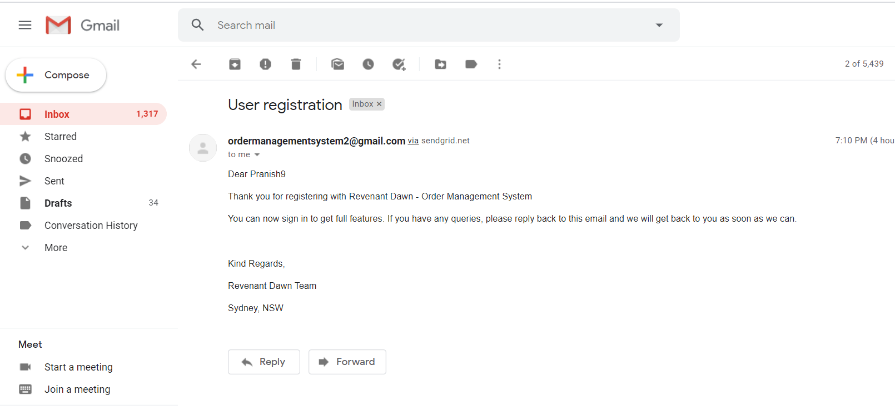

# Forgot password

If the user forgets the password, they can reset their existing Username.

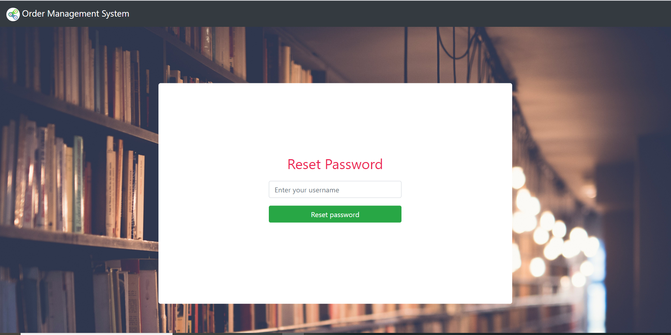

If such user exists, they will be redirected to another page

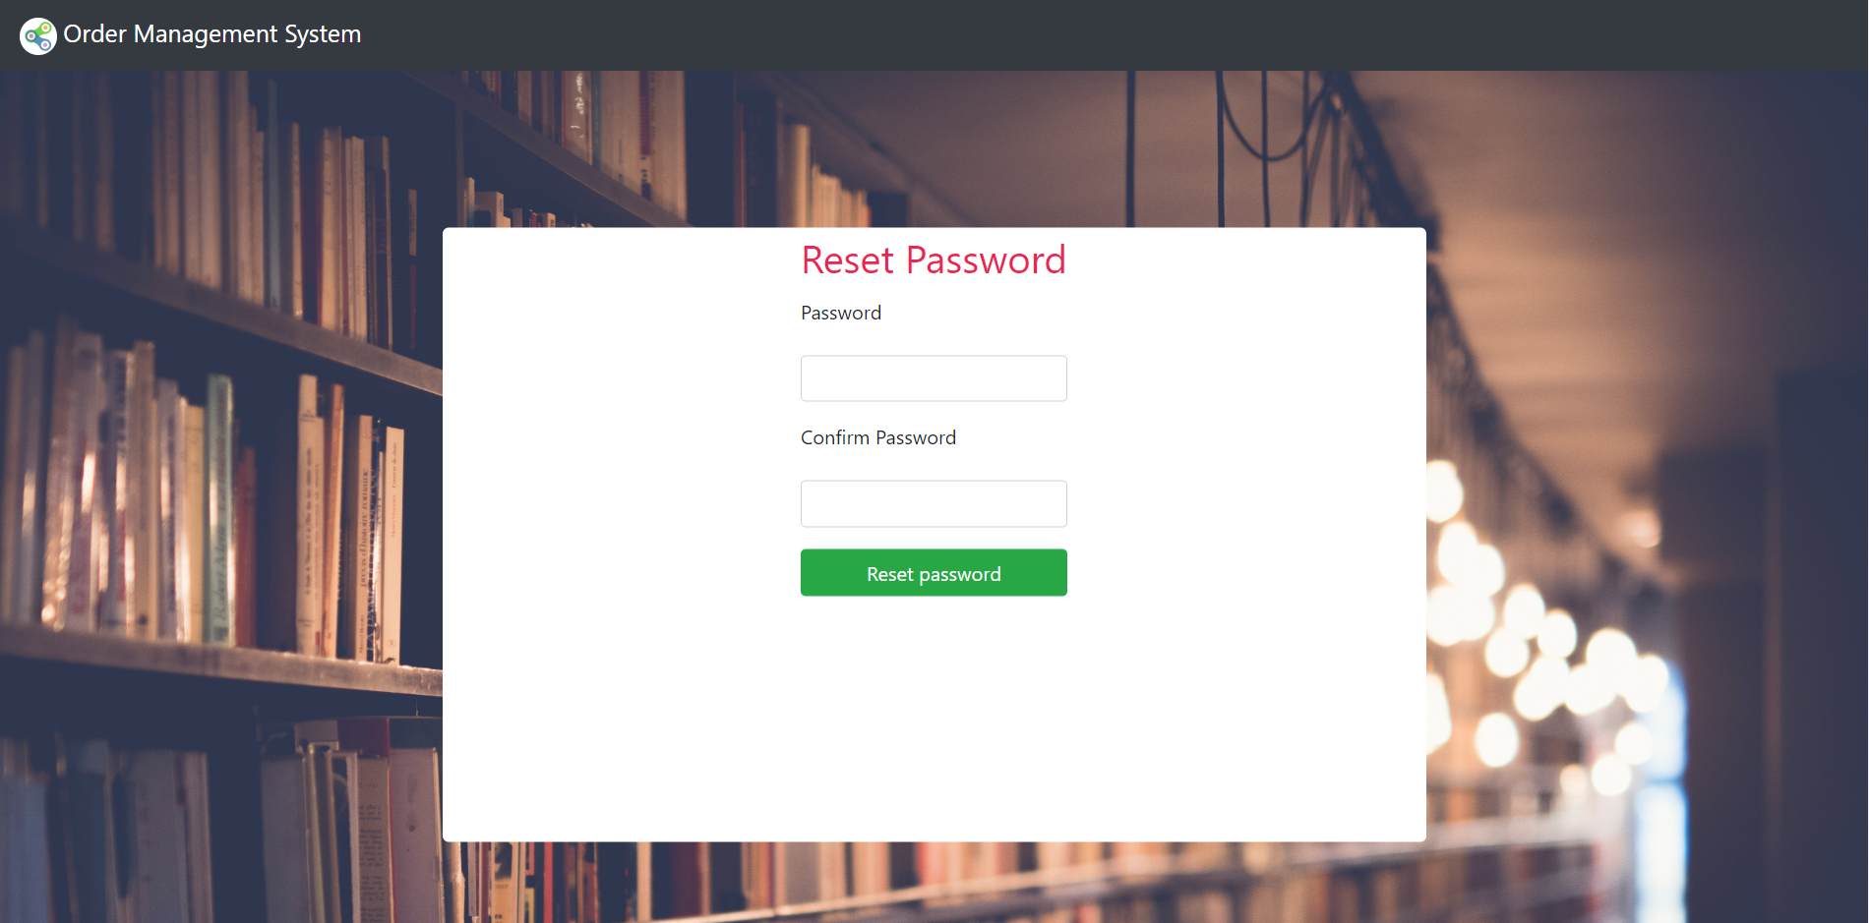

# Log In

User can login with their Username and password.

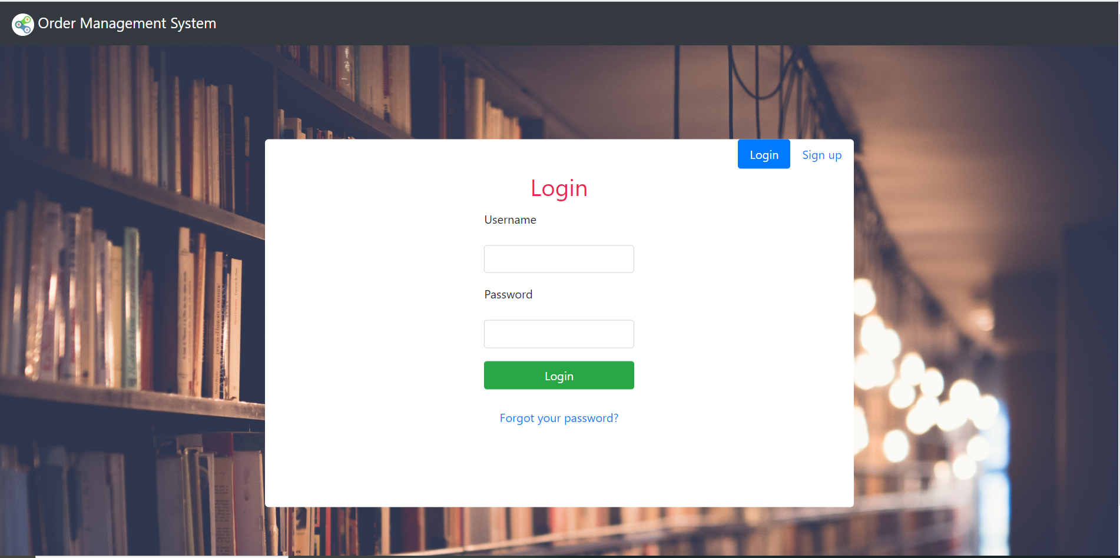

# Create an order

Service user can create an order and place it for the company. It means adding an Order by the user for what they wanted to order. User need to go to order page and again click on add order button and fill out the form to create an order.

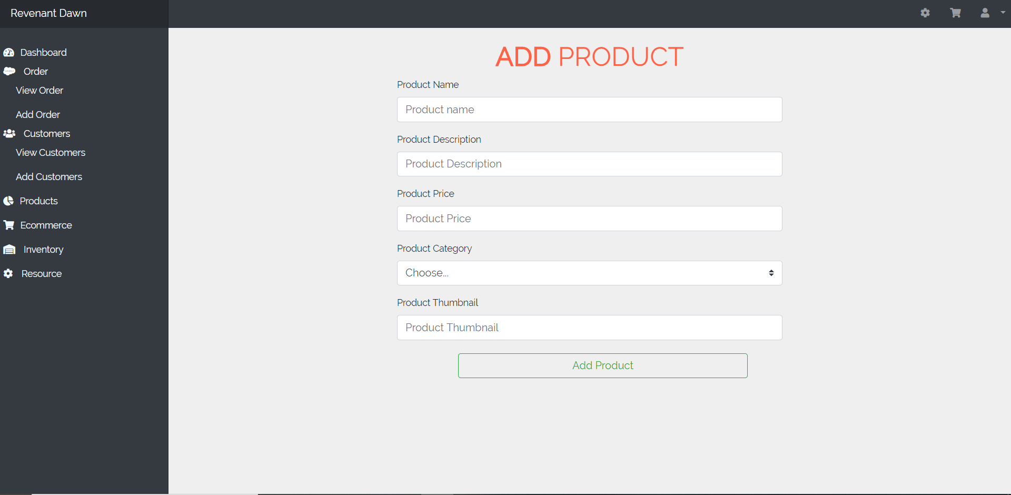

# Edit an order

Service user can edit or update an order.

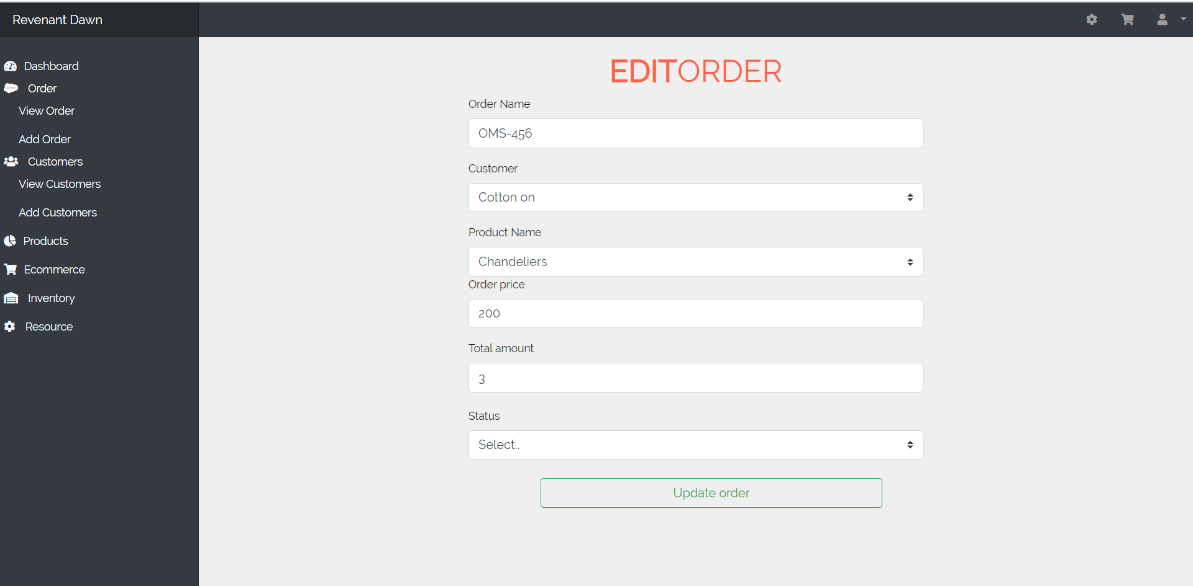

# Logout

Users can logout from the website by clicking on user icon which will create a dropdown and finally logout.

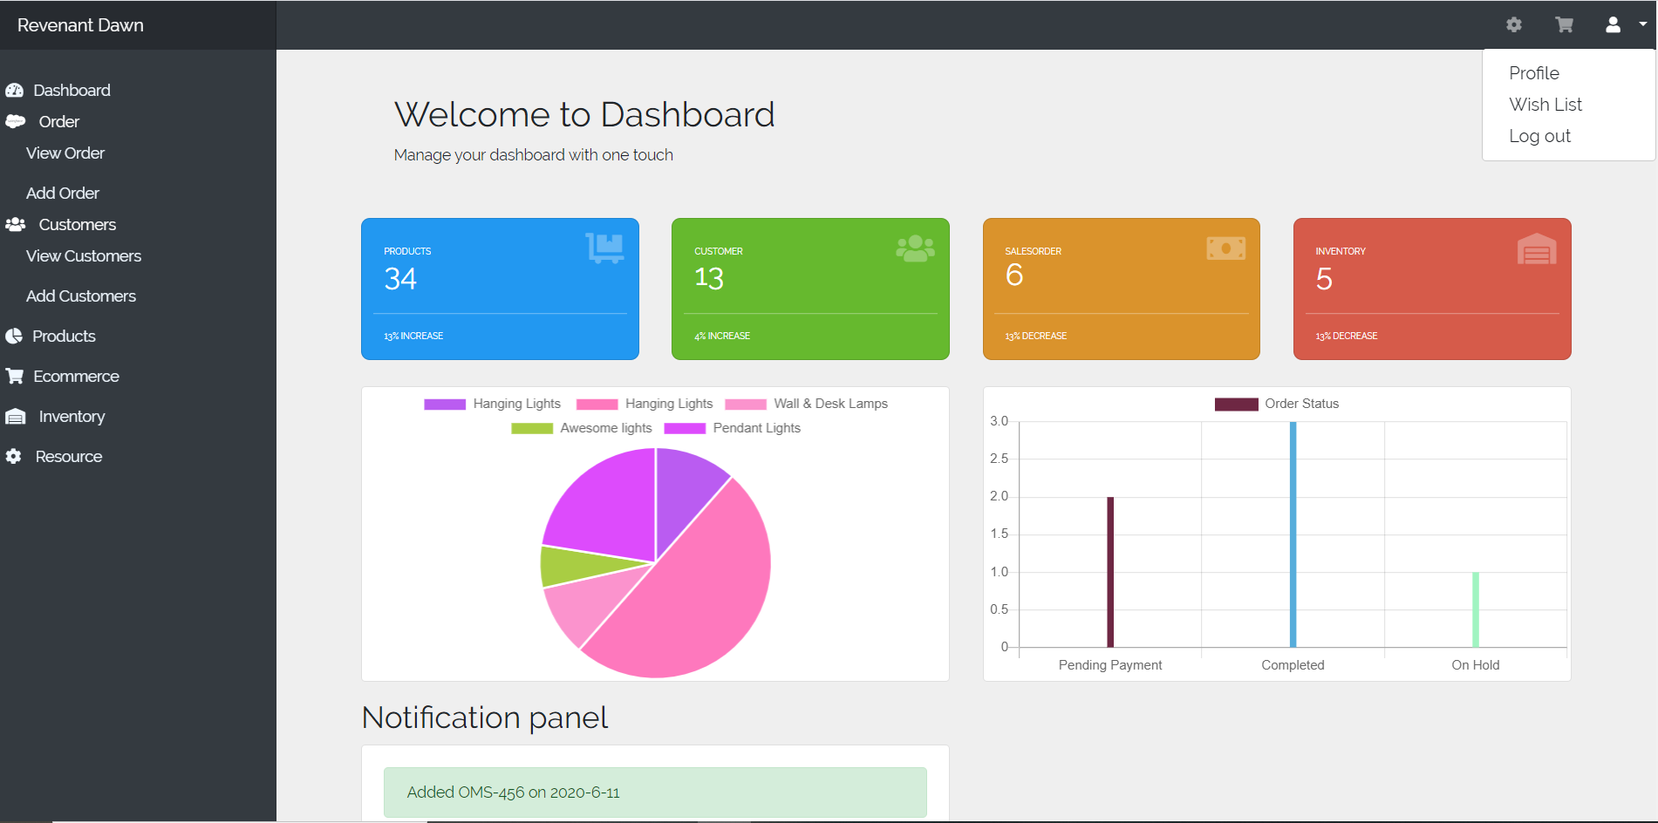

# Find the customers

Logistic manager can search through the list of the customers and contact the customer they search for.

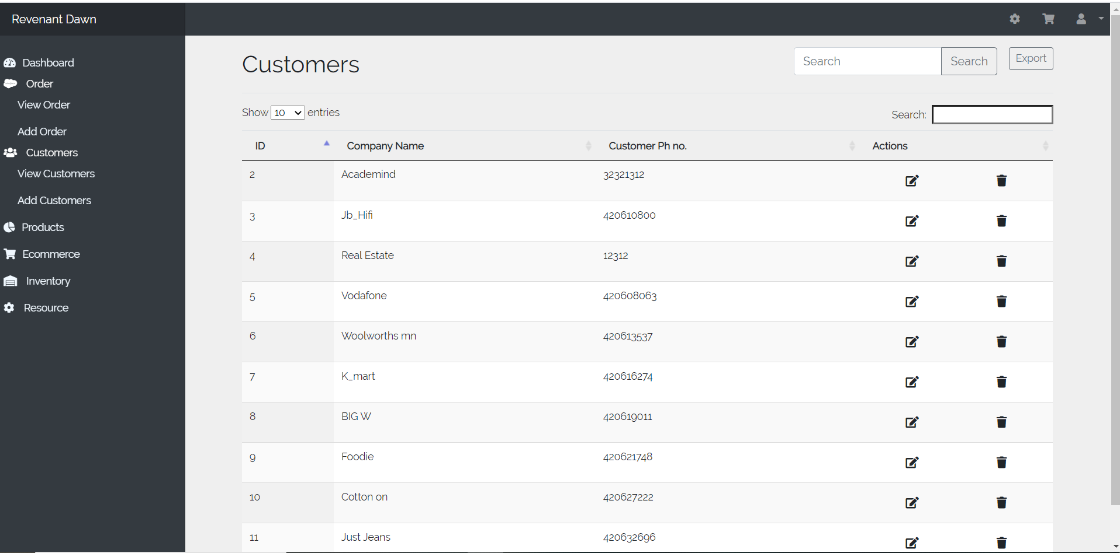

# Delete shopping cart products

Users can easily delete the products from the shopping cart by just clicking delete (trash icon). And it will not be displayed again until users add it back in the shopping cart.

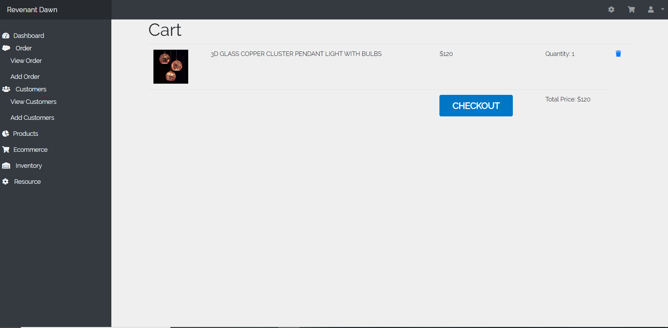

# Manage the inventory

Admin can manage the inventory so that there will not be scarcity of the products.

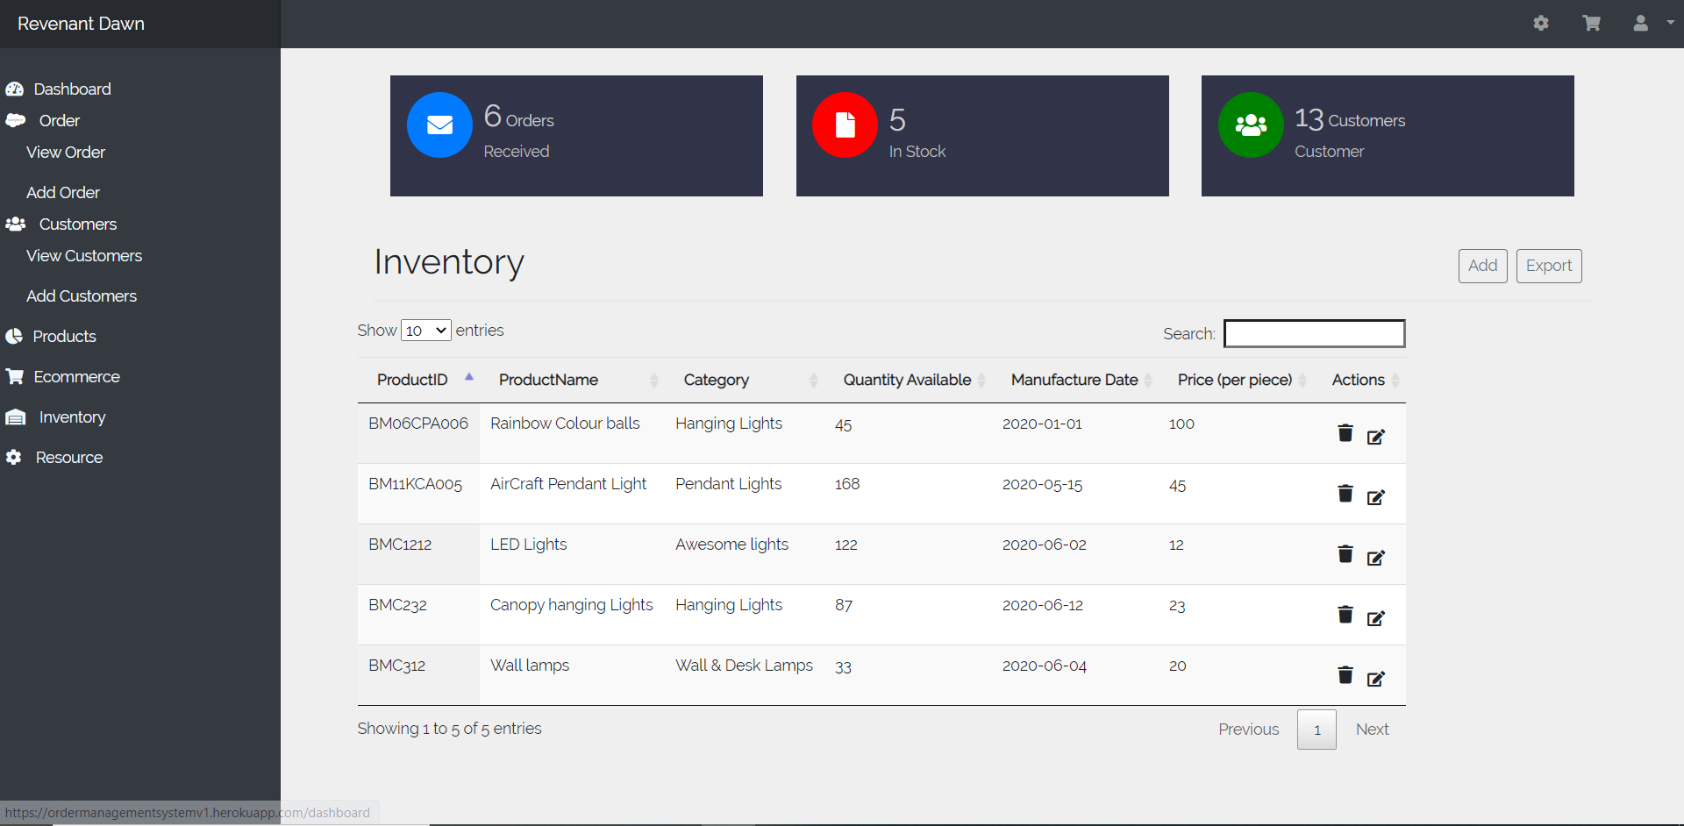

# Check the delivery time

Service users can check the delivery time so that they can make up to date with shipment.

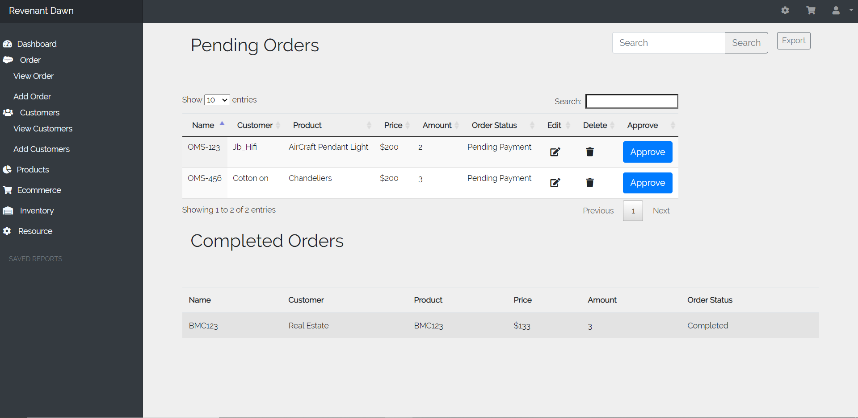

# Make payment

User can check out the item with their Billing information’s like Name, Email and address and it is available when the user click on cart panel. User can check out with the help of credit card as well as PayPal for easy payment.

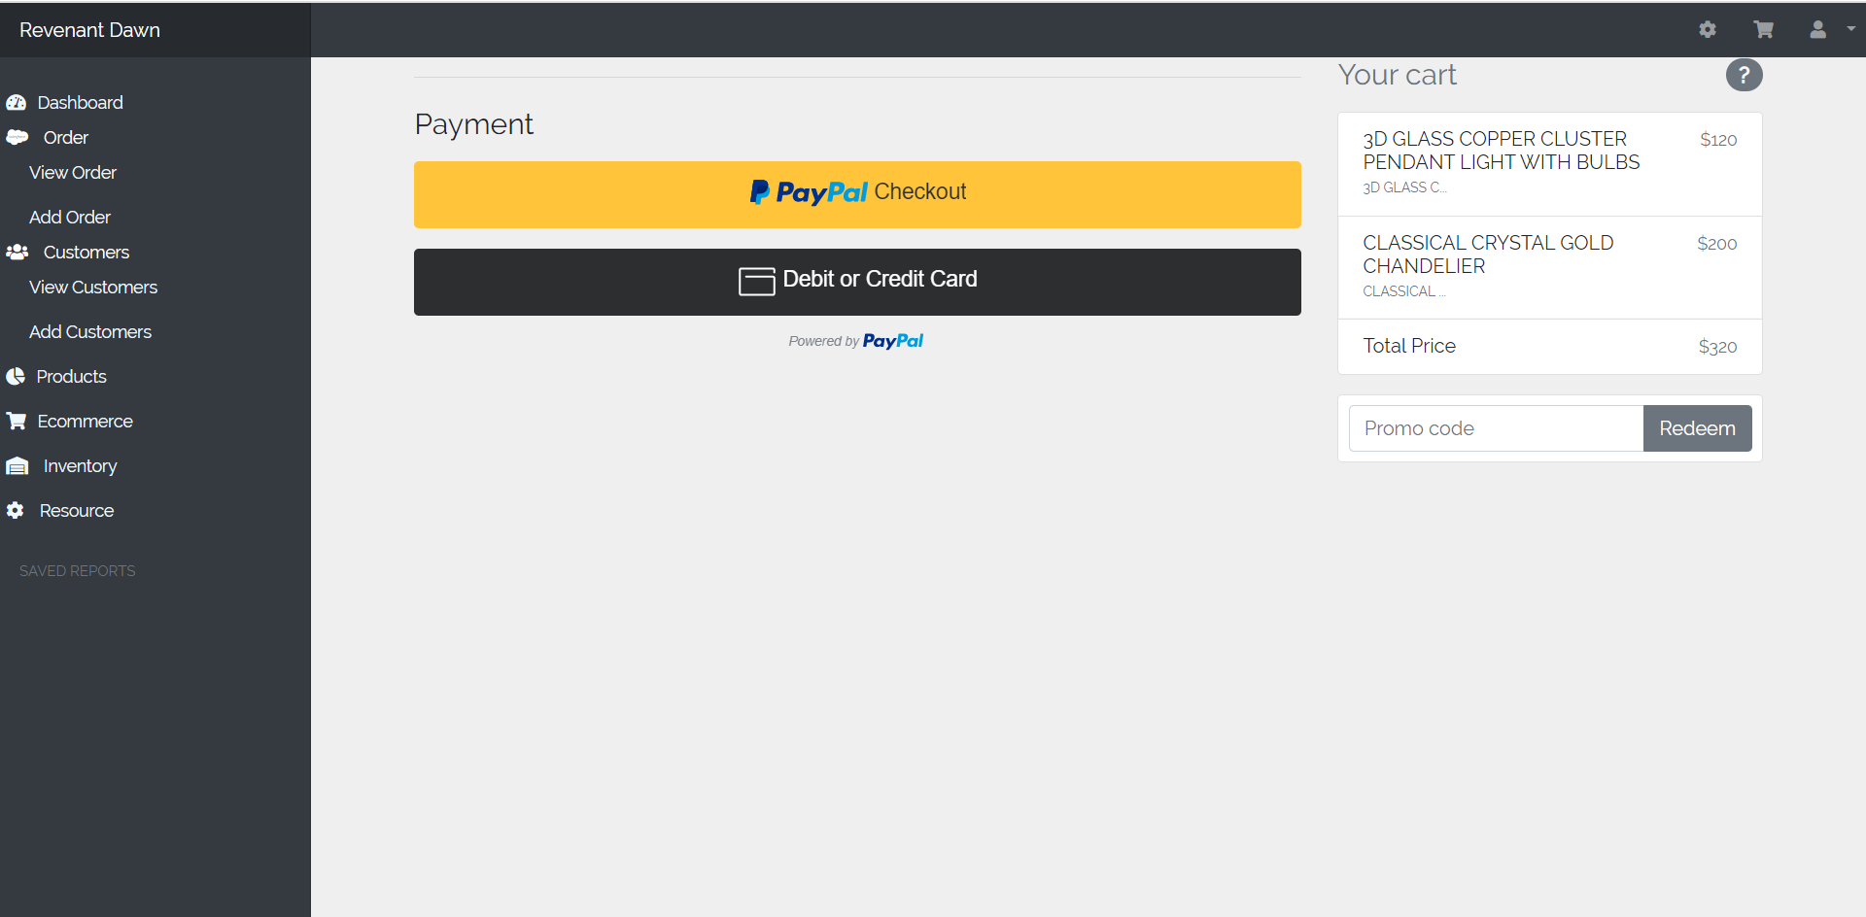

Clicking on PayPal checkout will redirect to PayPal login.

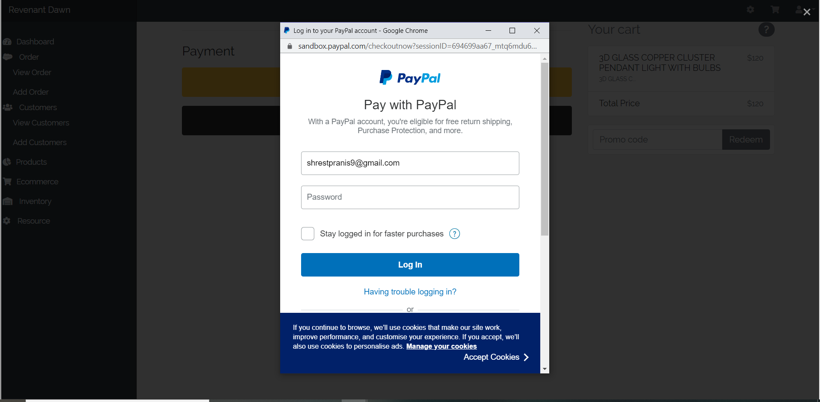

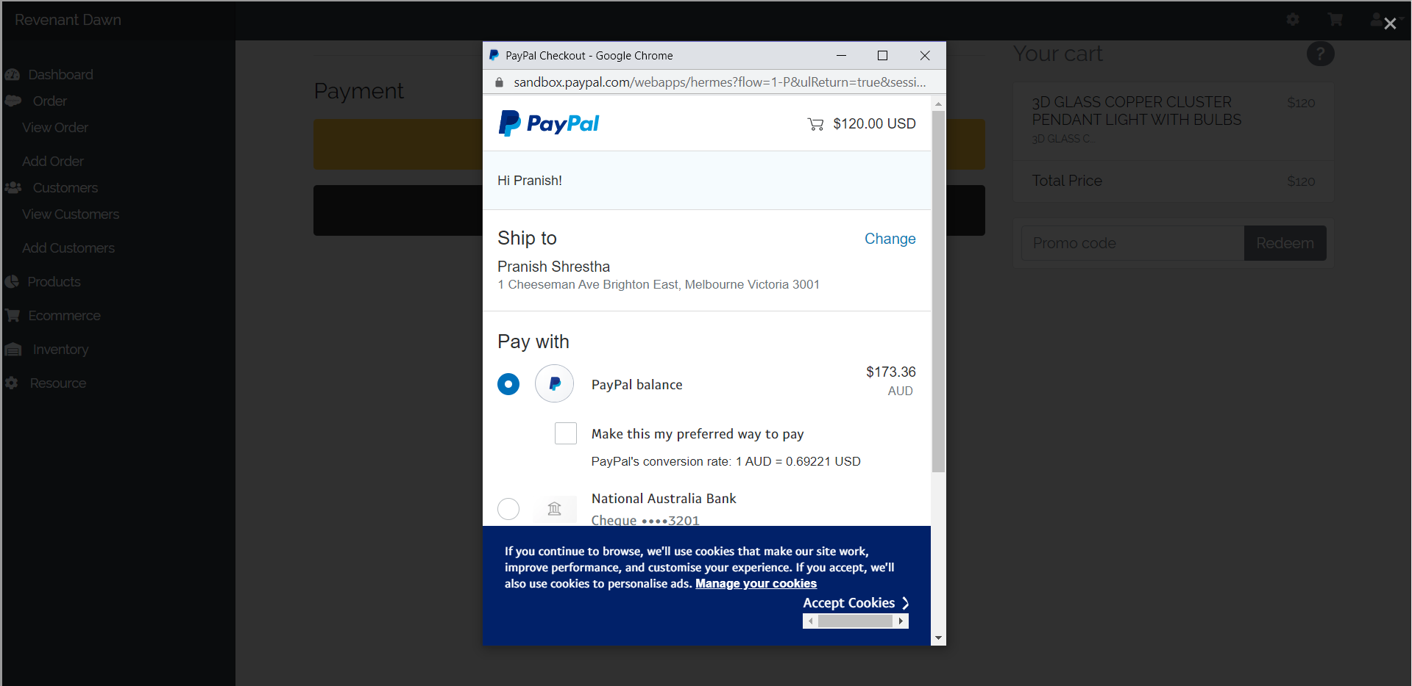

# Print a tax invoice

Users can print a tax invoice so that they can keep the evidence of their purchases. They just need to click on the print button which will be at the top of the page.

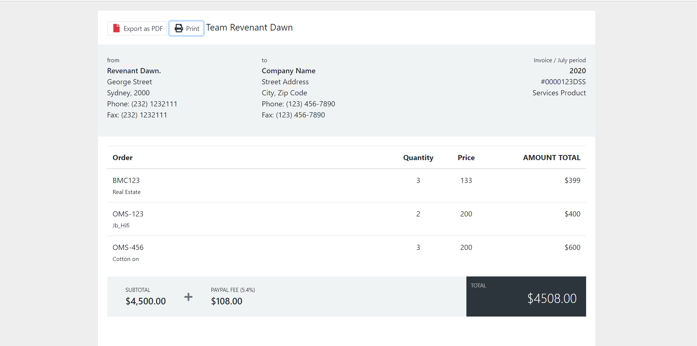

# Feedback

Users can give the review to the products. They need to fill out the form and send it to the respective person.

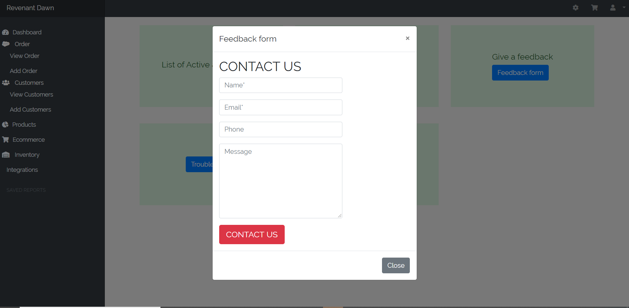

Filling out form will send email to the email that is put on the form.

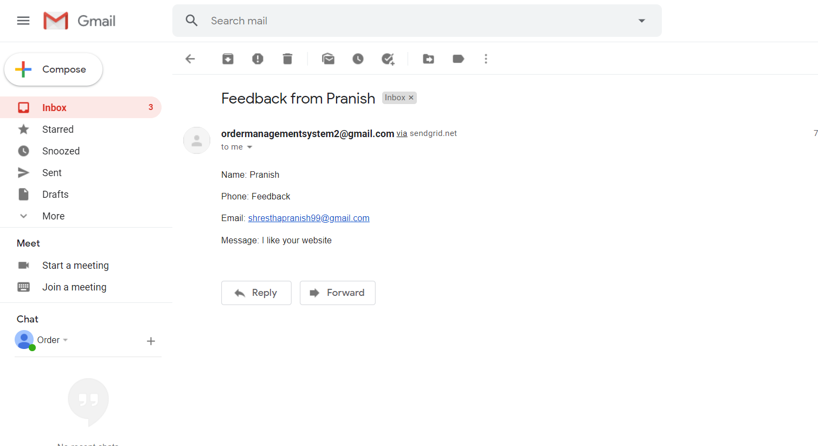

# View/edit Profile

Profile of the user details regarding their Name, User type, Email and Phone Number. Users can view their profile and can edit their profile. They just need to click on the profile icon which is at the top right corner of the website.

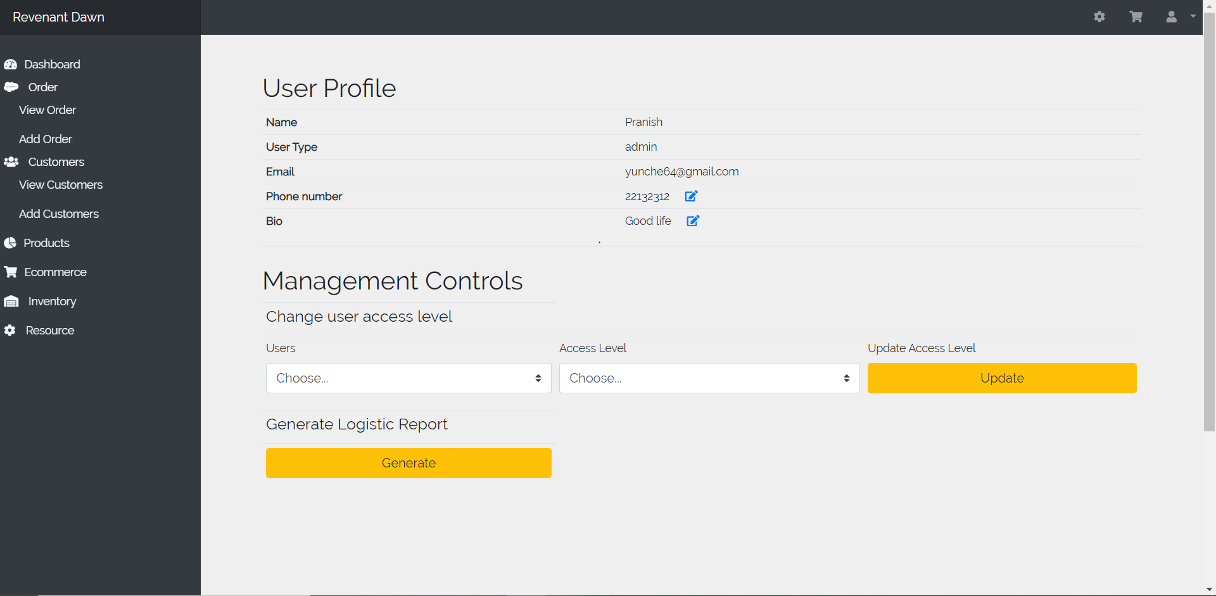

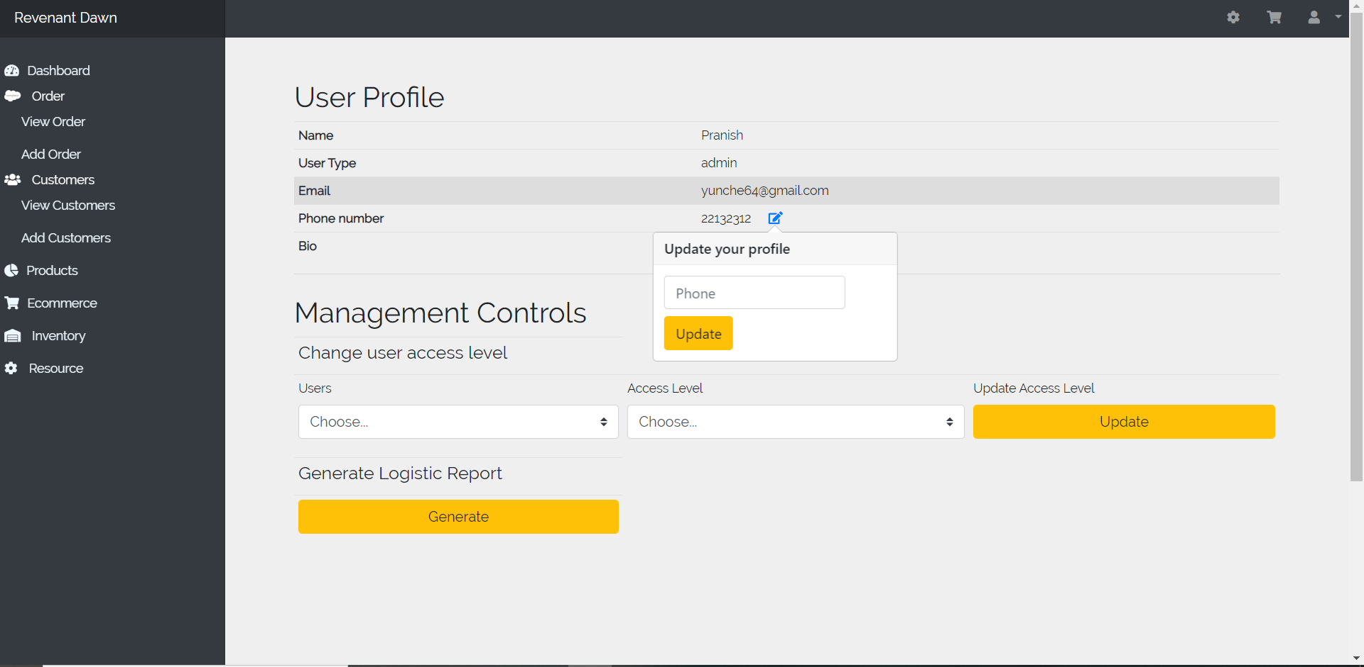

# Create/ manage categories

Admin can create or manage categories for every product so, it will be easy for users to get the products easily.

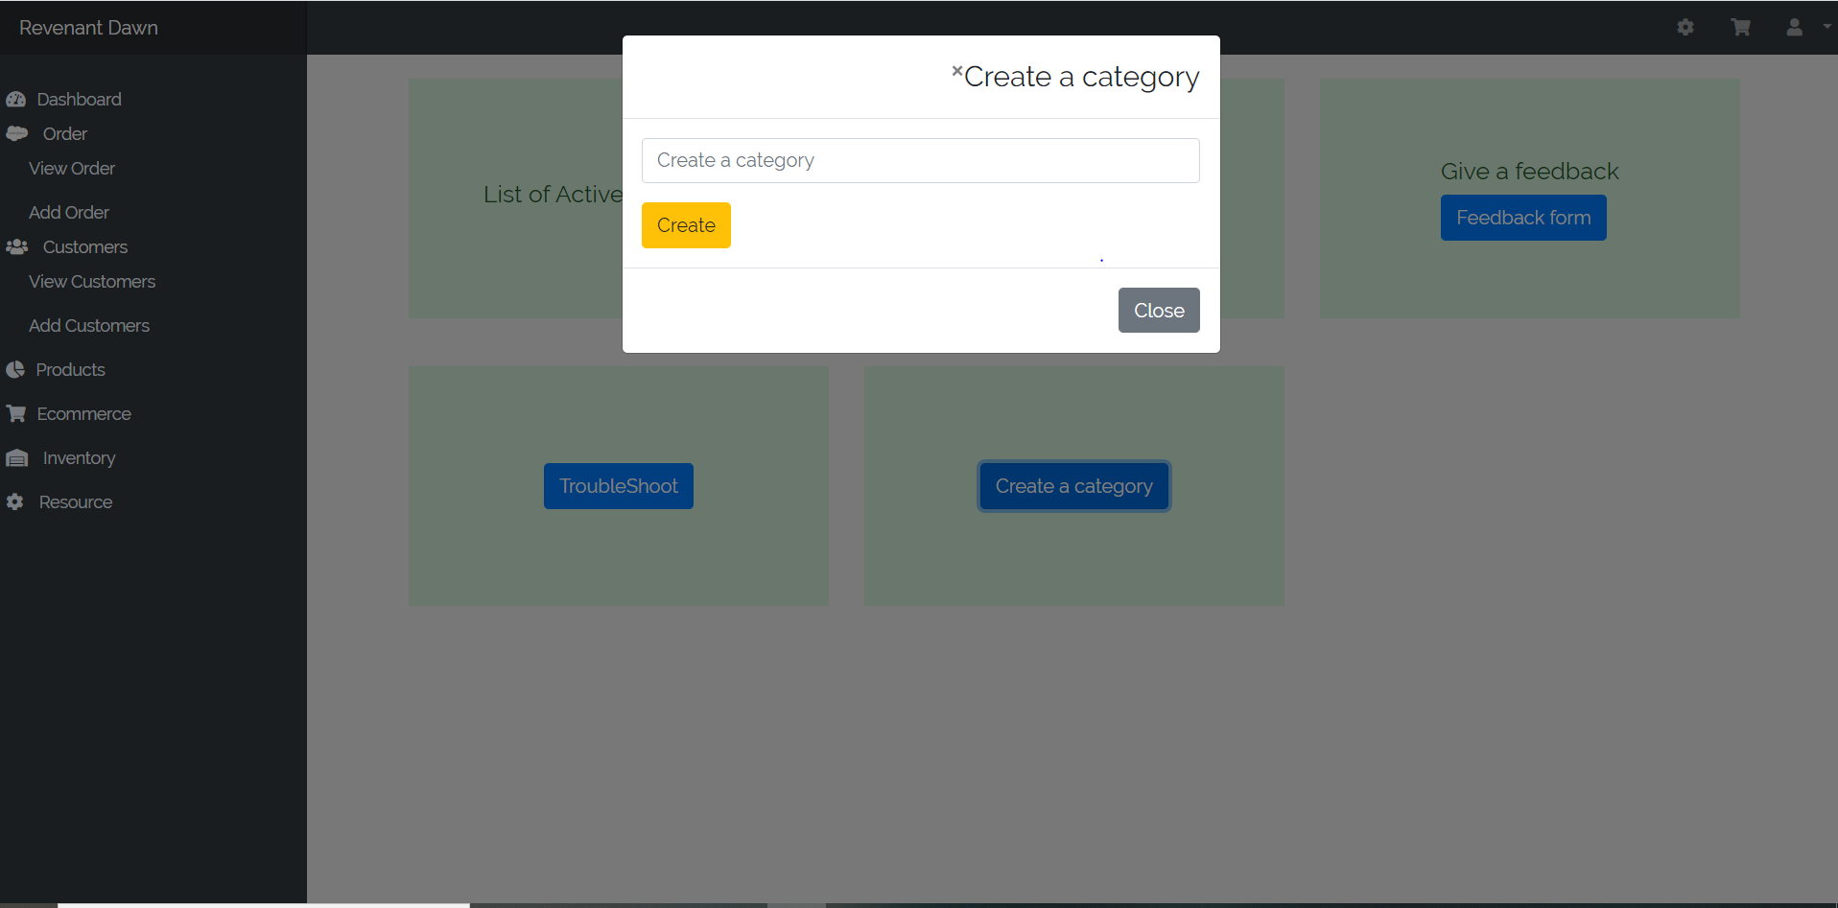

# Track shipments

Users can easily track the products using product id on the actual tracking website. They need to enter their order number and it will display all details about the products.

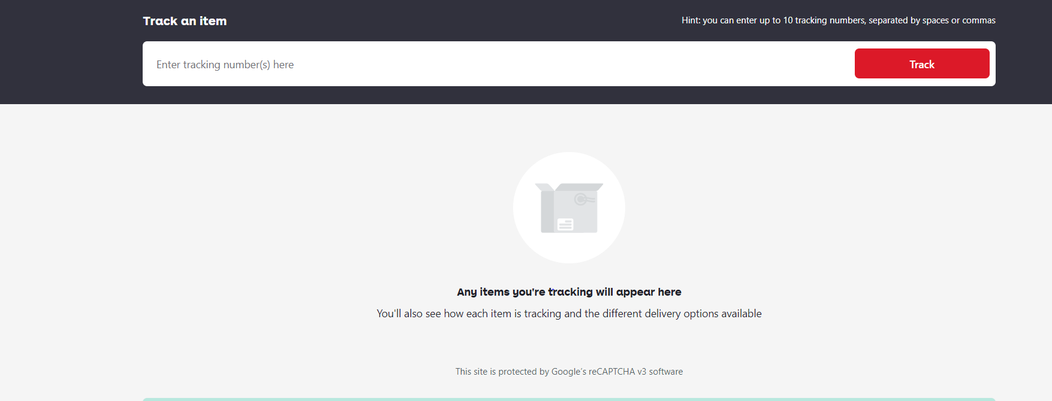

# Shopping cart

Users can select the products and add it to the shopping cart by just clicking on add to cart button and they can make payment from there.

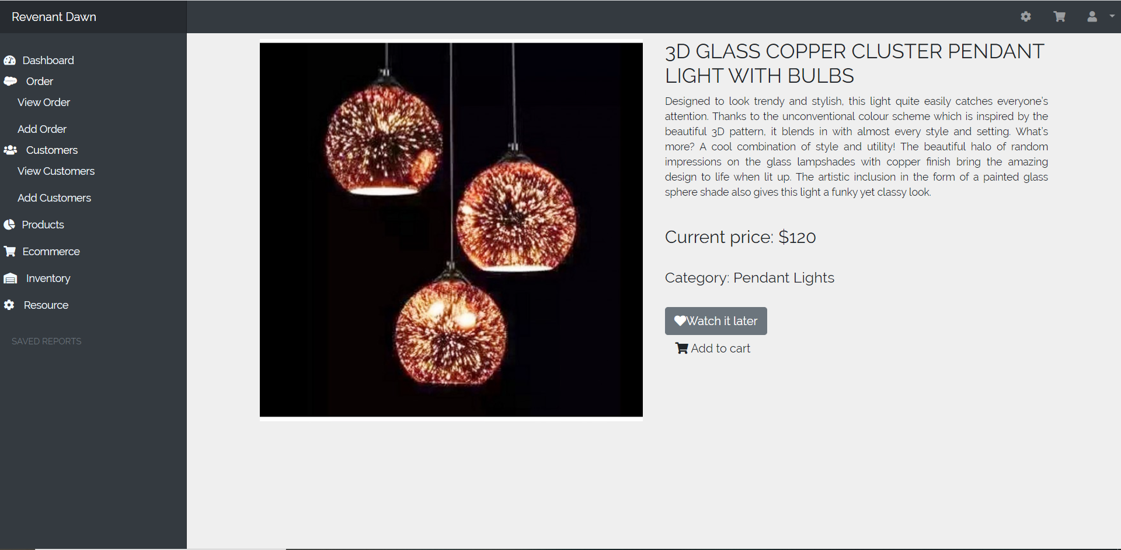

# Confirmation email

Users will get the confirmation email after the order is successful. Email will be forwarded to the verified email address only.

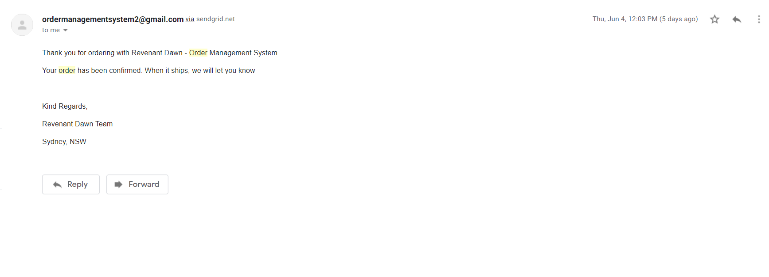

# Online accounts

An administrator can see the list of online accounts and also the number of users who has our website account.

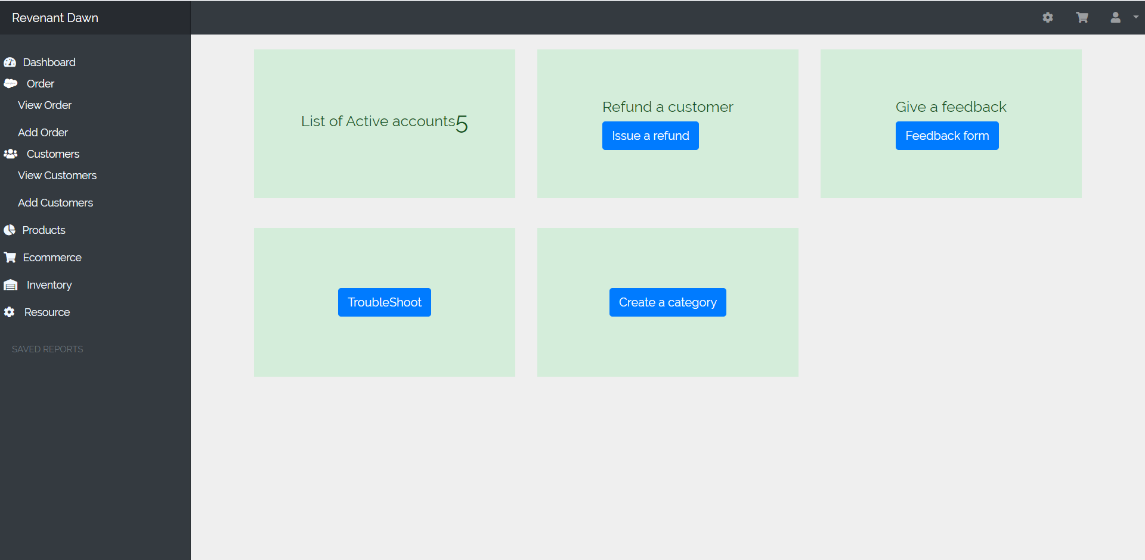

# Refund

Users can apply for the refund. They need to fill the form and submit the form along with the reason to refund.

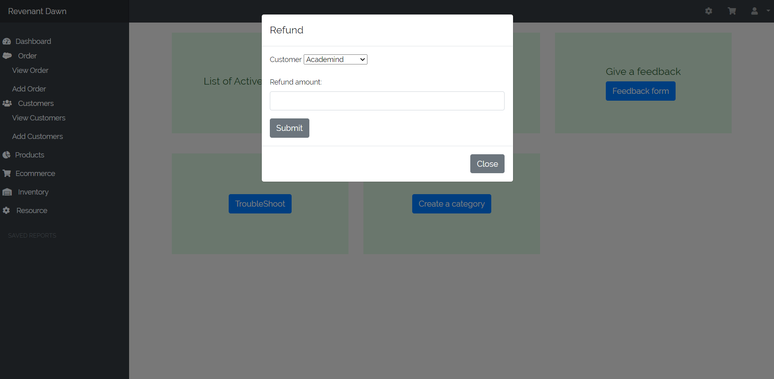

# Enter promotional codes

Users can enter the promotional code to get the 20% off on products. They need to use the valid code and it can be use once.

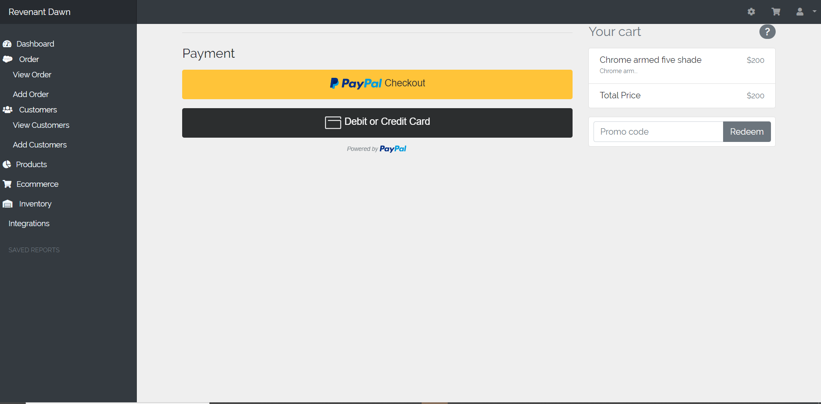

# Check the Stock through product cards

Product cards will show how many products are in inventory, how many customers are added in the system.

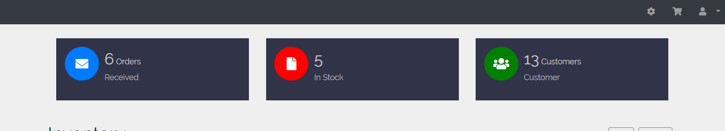

# Creating the inventory stock

User can create inventory stock products by filling out the details on the form which will add inventory items.

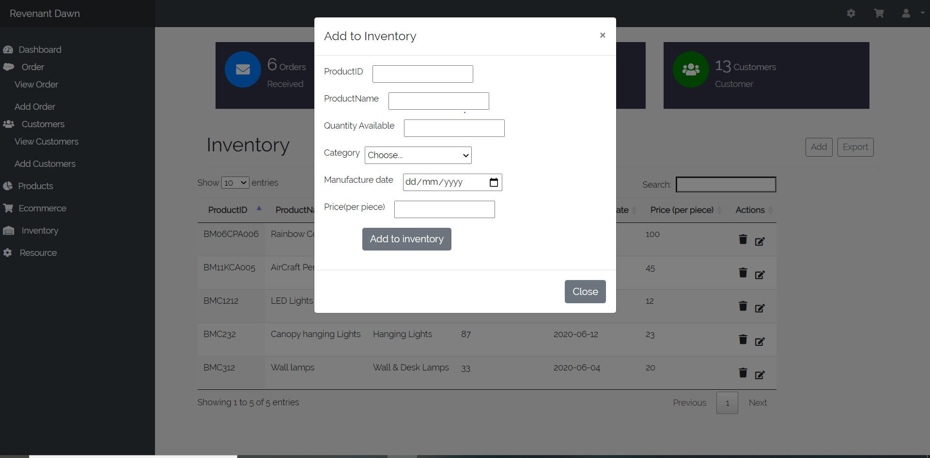

# Creating Backup in local storage

Clicking on the export button will create a csv file containing all the data from the tables which can be imported to database if it gets corrupted or lost.

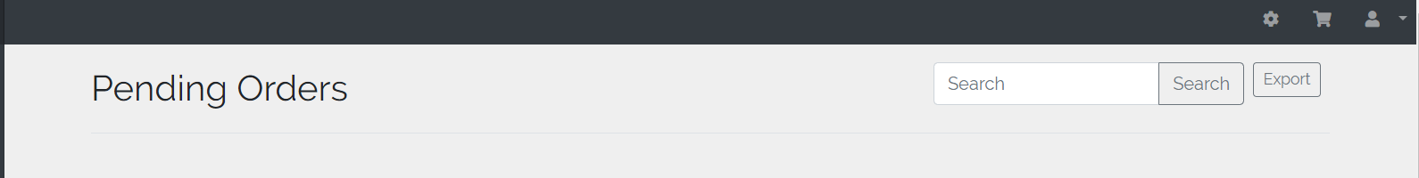

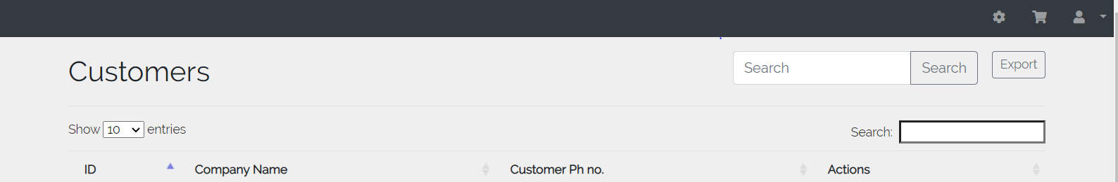

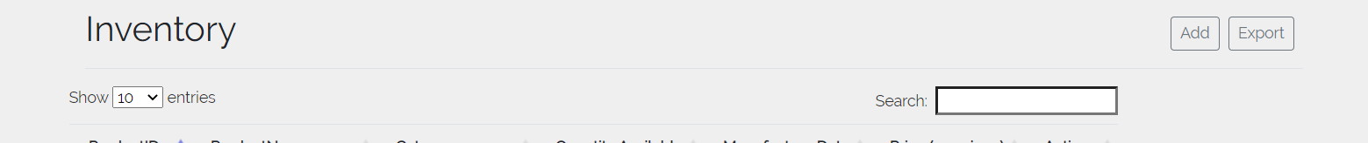

# Editing inventory Details

User can edit the inventory item details by clicking edit icon beside each product.

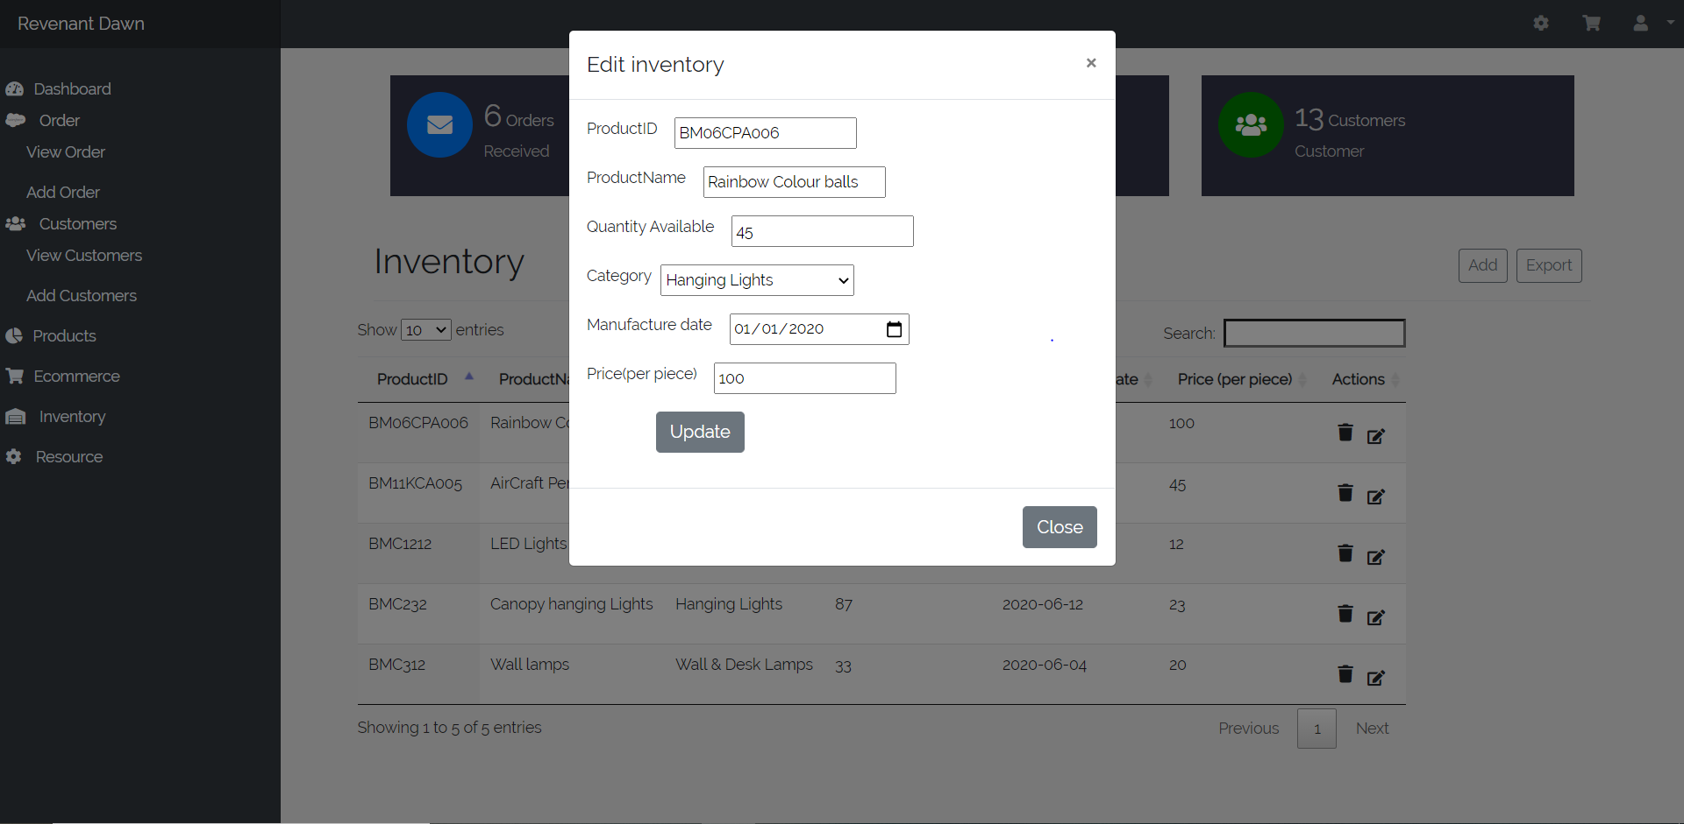

# Viewing the pending orders

It means User’s viewing the items which they wanted to order. Users can click on shopping cart Icon and view order button to view the pending orders.

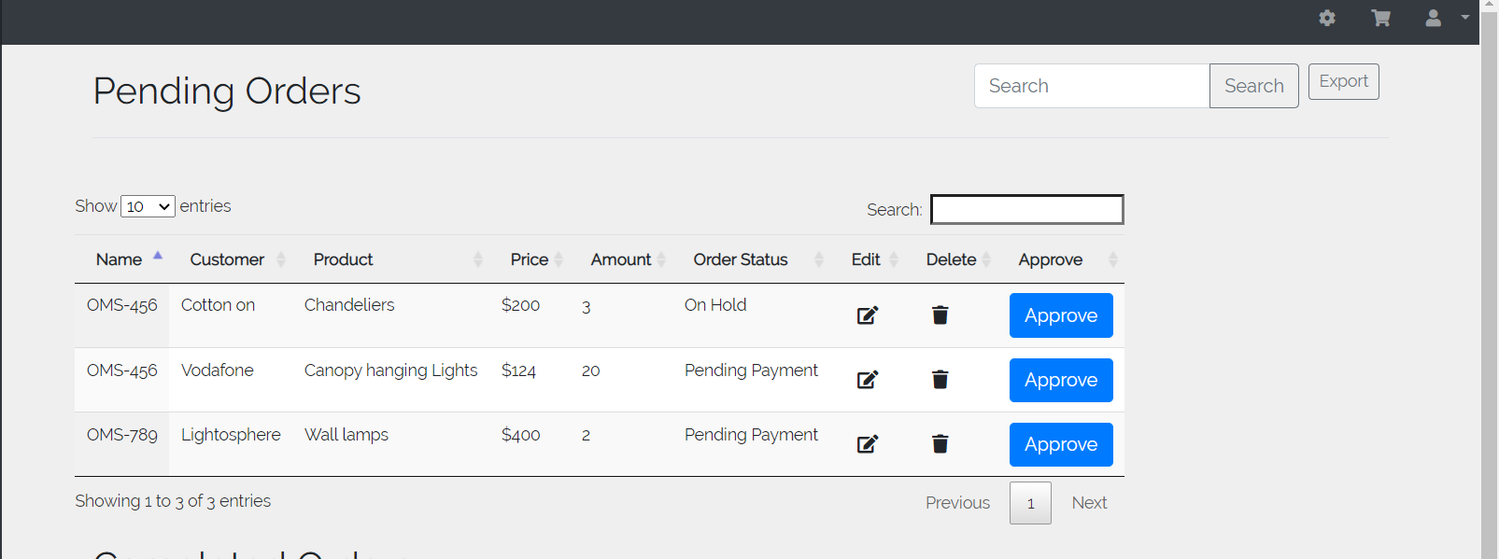

# Editing Order

Users can edit the order as per their demand. They need to need to go to order page and again click on edit order button and fill out the form to edit an order.

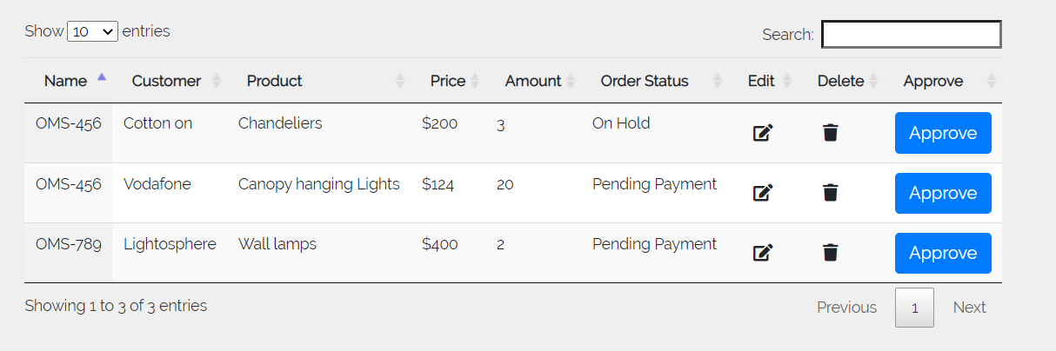

Clicking on edit button will lead to this page from where we can edit order details.  
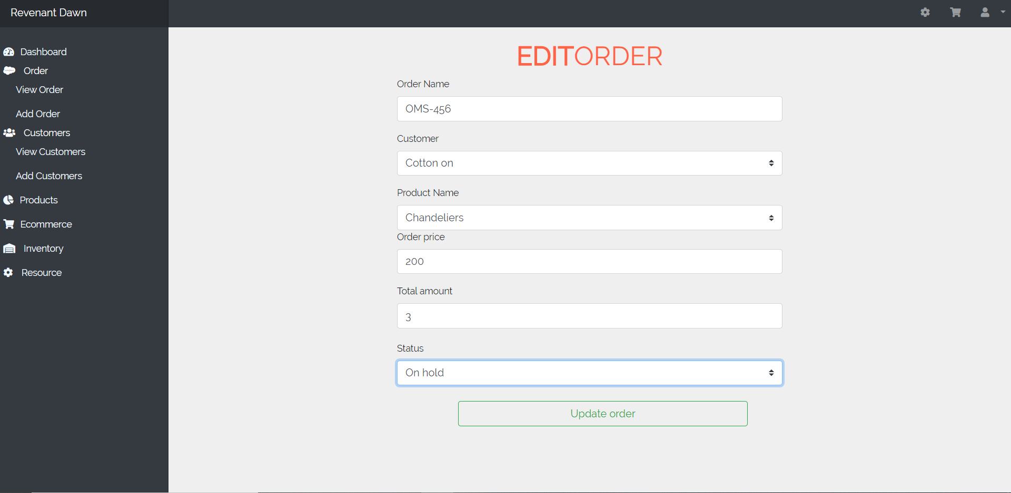

# 

# Generate Logistic report

Admin users can generate logistic report by clicking generate button in the profile tab which creates a pie chart based on inventory to manage stocks.

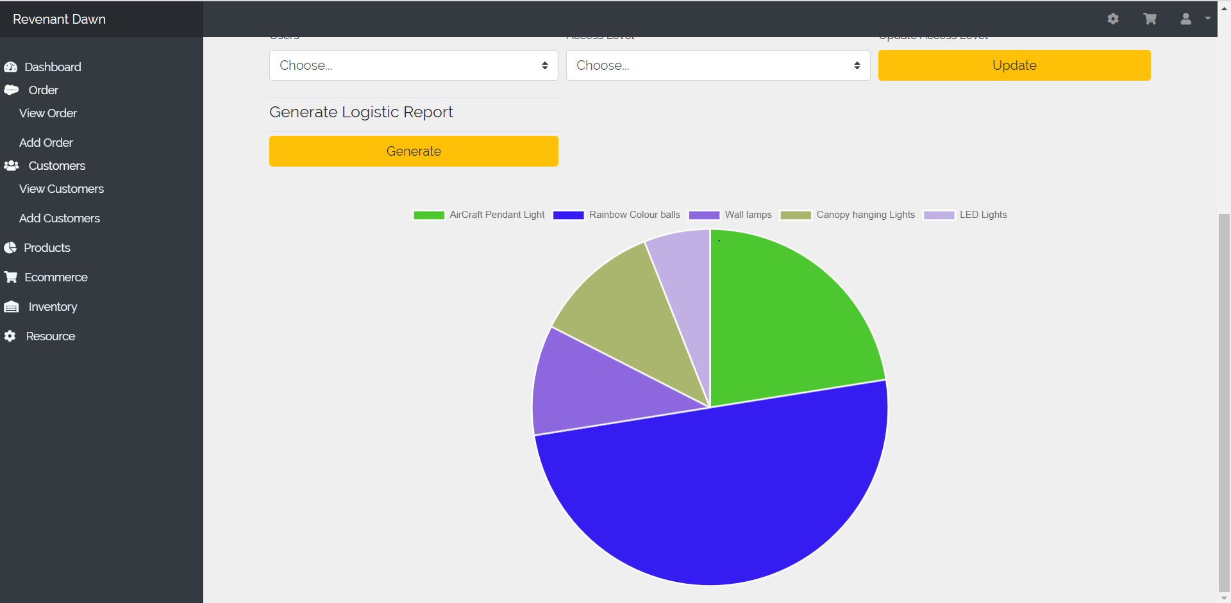

# Notification Panel

Recent Information are provided in the notification panel. It is located at the bottom of the dashboard.

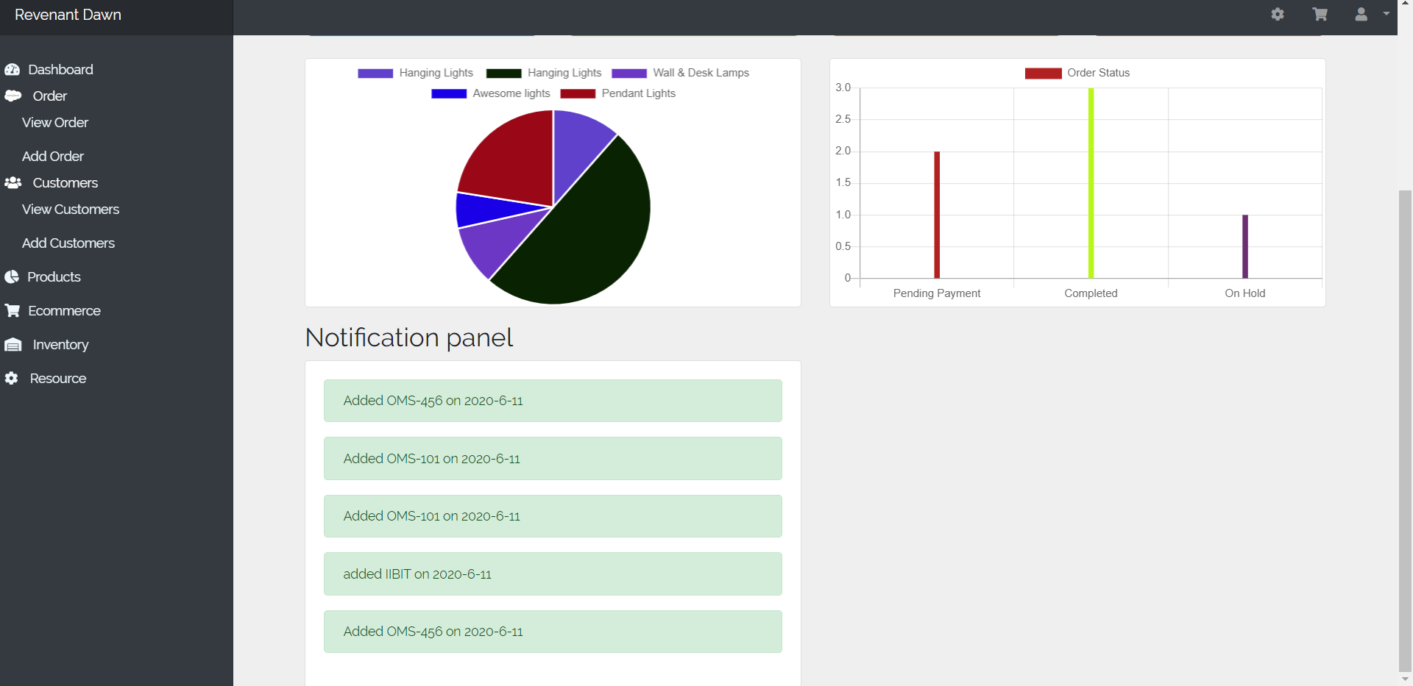

# View Items by Category

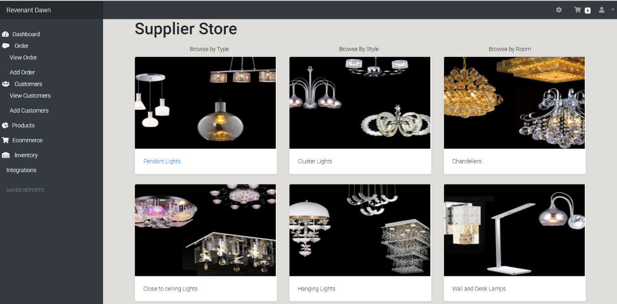

# View product Detail

User can view information and add to cart section after choosing the specific product in ecommerce tab.

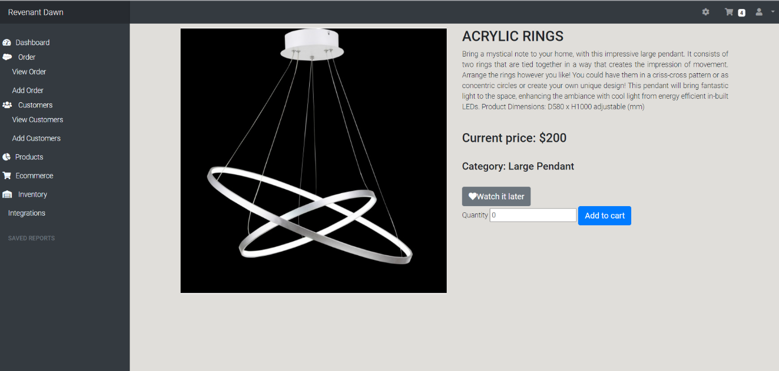

# Watch it later Section

Product can be enlisted by the user to wish list when they want. It is located at the top right corner of the website.

Clicking on clear Wishlist will clear out all Wishlist stored

